How to Write Using Microsoft Word

**How To Import/Insert Pictures/Images From File In Word**

You can insert images or pictures by using the Word build-in Picture utility.

1.Put the cursor on the place where you want to insert pictures, and click **Insert > Picture.**

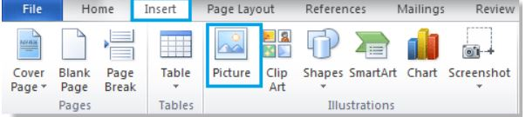

2.After clicking Picture, it will display an Insert Picture dialog. In this dialog, open the folder which contains the pictures you want to insert, and then select the pictures and finally click Insert to insert the selected pictures.

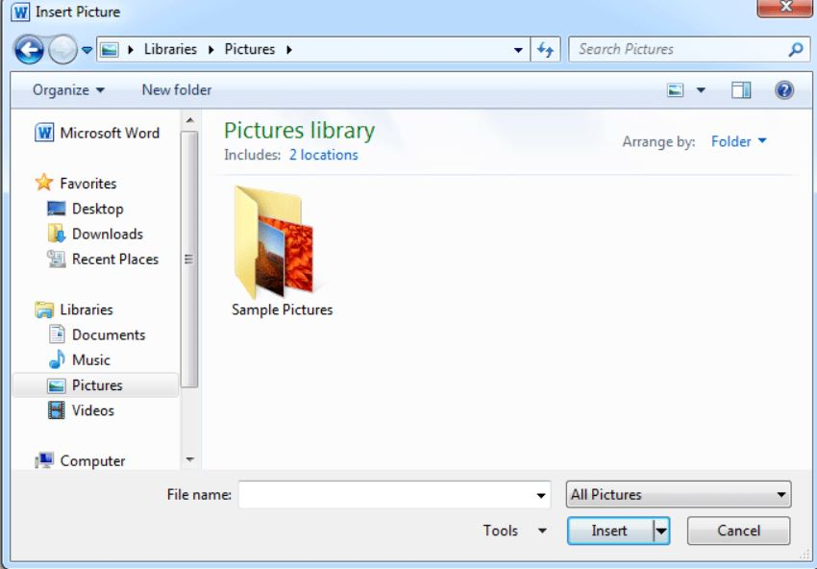

1. If you want to insert multiple pictures from the same folder, you can hold Ctrl key to select the pictures one by one.

2. If you want to insert a picture folder, please select the folder, and click Insert.

**Insert Multiple Pictures With Kutools For Word**

If you have a folder contains all the pictures you want to insert, you can quickly insert the whole folder pictures to the document at once instead of selecting them one by one with Kutools for Word’s Images utility.

1.Step

Click Kutools > Insert > Images

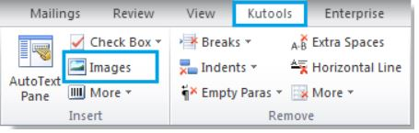

2.Step After clicking Images, there will be an Insert Pictures dialog popping up. In this dialog, you can:

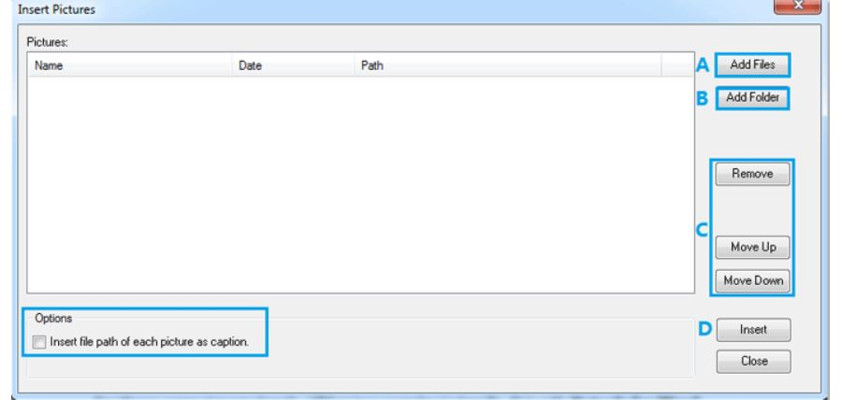

A.**Add Files**: You can add a picture or multiple pictures by clicking this button;

B. **Add Folder**: Add all pictures from the whole folder by selecting it;

C. **Remove**, **Move Up**, **Move Down**: You can use these three buttons to delete or rearrange your pictures;

D. **Insert**: please click Insert button to quickly insert pictures.

**Note**: under **Options**, you can also choose to insert file path of each picture as caption by checking the box.

For more detailed information on**Images**, please go to [Images](https://www.extendoffice.com/product/kutools-for-word/word-insert-multiple-pictures.html).

**How To Change Text Direction In Word**

Step 1.Click Insert in the Ribbon bar >> Text Box and choose a style from the drop-down menu. & click Insert> Shapes and choose a style from the drop down menu. Insert a text box or draw a shape at cursor position where you want to change text direction. Type the text into the text box or shape.

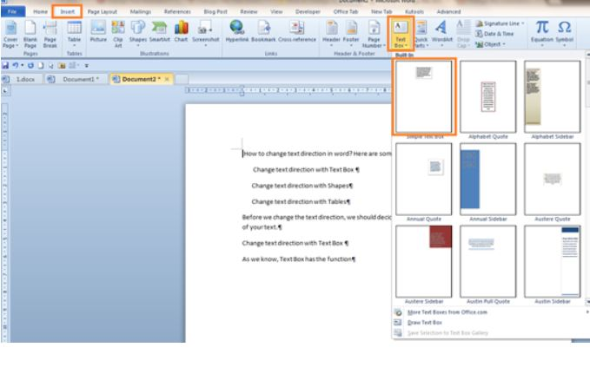

Step 2.Click the text box or shape > click Format on the ribbon bar > click Text Direction

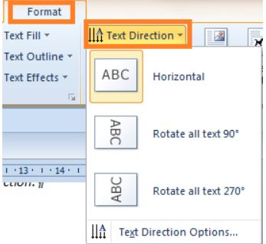

Step 3.Select the direction you prefer from the Text Direction drop down menu.

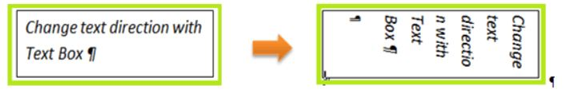

**Change Text Direction In A Table**

Step 1: click Insert > Table to insert a table at the cursor position and type the text into the table

Step 2: choose the cells that contain the text you want to change direction. Click Layout on the ribbon bar >Text Direction.

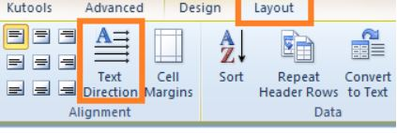

Step 3: click the **Text Direction** to change the direction of text .

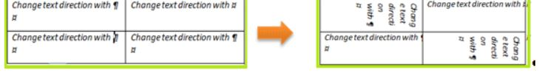

Alternatively, you also can Right click the selected text to select the direction you need

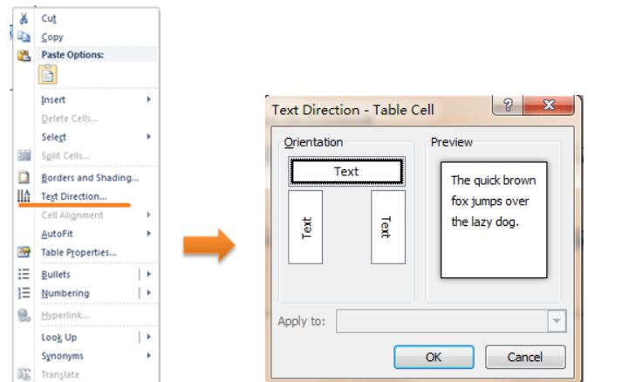

**How To Insert Word Count Or Page Count In Word**

Step 1: Position the cursor where you want to insert word count or page count, and click Insert > Quick Parts > Field.

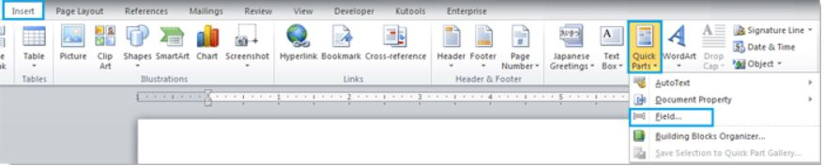

Step 2. Scroll down the Field names to select NumWords or NumPages.

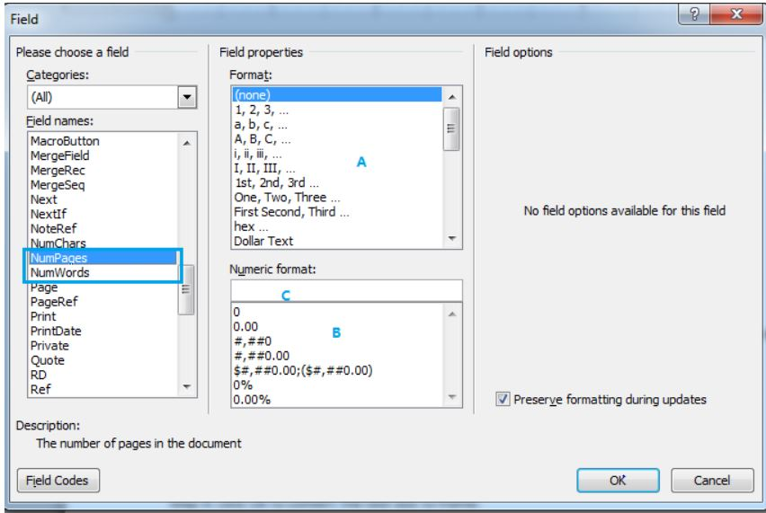

You can select the style of ordinal numbers you want in A or B, also you can type the style you like in C.

If you need to keep the formatting after update, please checkPreserveformattingupdates.

If you want to quickly findNumPages and NumWords, you can select DocumentInformation in Categories first.

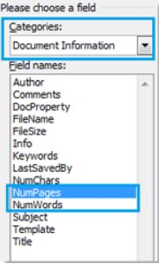

Step 3. Click Ok, it will insert the number into the place where you cursor on.

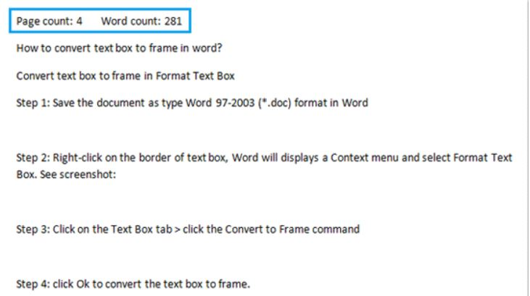

if you add and remove text from your document, select the word count number and page count number and Right click it to select Update Field to update the word count or page count automatically

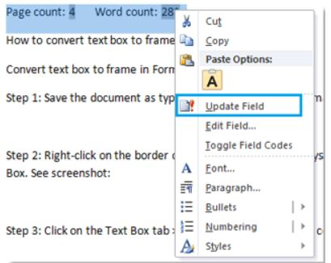

задача 2